Running the Laning-Zierler Compiler-Interpreter on a Simulated Whirlwind Computer

***Draft – Not for Distribution***

Lawrence A. Stabile

January 26, 2026

## Abstract

An algebraic language, preceding Fortran, was developed for the Whirlwind computer in 1953 by J. Halcombe Laning Jr. and Neal Zierler. Starting from a hand-written listing of the program in Donald Knuth’s archives, and two typewritten libraries, we have produced working code of this language, on a simulated Whirlwind computer. The system compiles the algebraic language into instructions which are then interpreted. In this paper we describe the effort required to transcribe, assemble, and debug this program, and offer some comments on the design of the code and Whirlwind software development practice.

## Introduction

It is ironic that the Whirlwind, one of the first computers designed for real-time computation, spawned one of the first high-level computer languages — via a decidedly non-real-time interaction.

The Laning-Zierler compiler-interpreter, initially developed in 1953 by J. Halcombe Laning Jr. and Neal Zierler, took a major step in advancing high-level languages toward modern forms, allowing expression evaluation, assignment, labeling, and conditional or unconditional branching. It was a forerunner to Fortran.

A user interacted with the system via the Flexowriter, a keyboard/printer/reader/punch. Punch here is to paper tape, and the interaction is to type on the keyboard to punch the tape, possibly load the tape onto a separate reader, read the tape into memory, and execute the program, which prints the results to the Flexowriter printer.

The Flexowriter had its own paper tape reader, but a Ferranti photoelectric reader [2] used in Whirlwind was much faster and justified requiring the user to move the tape. Printing also required some waiting, as printing a single character could take 125 milliseconds. Contrast this with other Whirlwind peripherals: X-Y driven oscilloscopes, light pen input, radar input, and myriad (truly physical) switches and knobs. Flexowriter languages were not the real-time part.

The syntax of the LZ language is strikingly familiar. Figure 1 shows an LZ program and its corresponding output, on a virtual Flexowriter. This is produced from the original LZ code, running on Guy Fedorkow’s Whirlwind instruction simulator [1].

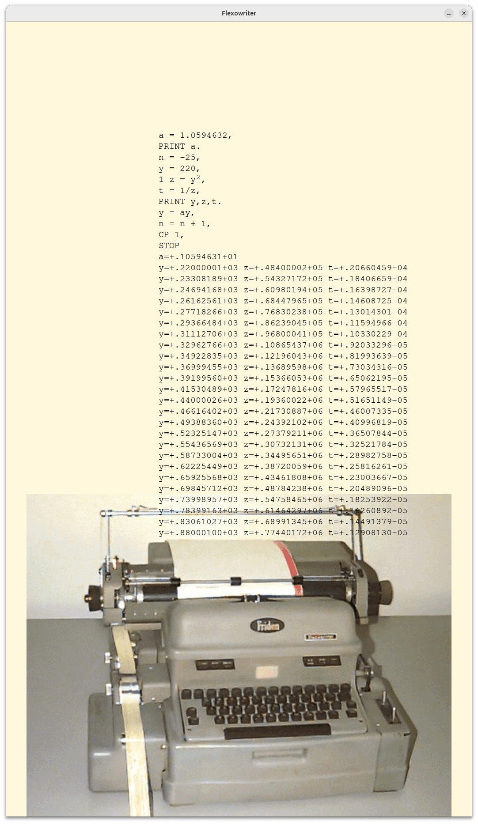Figure 1: Simple LZ program which prints musical note frequencies, their squares, and inverse squares, on a virtual Flexowriter. When set to original Flexowriter speeds, printing all the text above takes almost three minutes.

This effort began with the hand-written listing, the first page of which is shown in figure 2. There is a total of 20 sheets (see [7] for the full hand-written listing).

An additional boost was given by the availability of notes on the program by Donald Knuth, from 1976. [4] The listing as it turns out is also from Knuth’s archive, and it is his notes on the listing in light pencil. The first page of Knuth’s notes is shown in figure 3. See [4] for the full set of these notes.

The initial task was to transcribe the hand-written listing to text. This was done using syntactic conventions to capture the comments in the source, and also notes of the transcriber. We thus had a format which could be run through a simple parsing tool, which translated the transcript format to Whirlwind assembler.

Perusing the initial listing shows there are two external modules required by the LZ code, the floating-point arithmetic library, and the floating-point printer. The floating arithmetic library is available in the file Subroutines.pdf [10], a collection of modules in typewritten text. This module was ported and tested separately from the main LZ code, and is crucial to its operation, as is described below. It’s more than your average float lib!

We were unable to find the printer, but a printer of double-precision fractional numbers was in the library, and made a good starting point for a float printer. As a result we have a reasonable simulation of the original LZ system, all in Whirlwind code.

In the remainder of this paper we’ll go over some of the methods used to get it all to work, the issues encountered, and coding methods on Whirlwind. Note that comments about software development at the time, and some of the historical aspects of Whirlwind development, and software development in general, are based on my experience and recollections, and are not intended to constitute deep historical research on the topic.

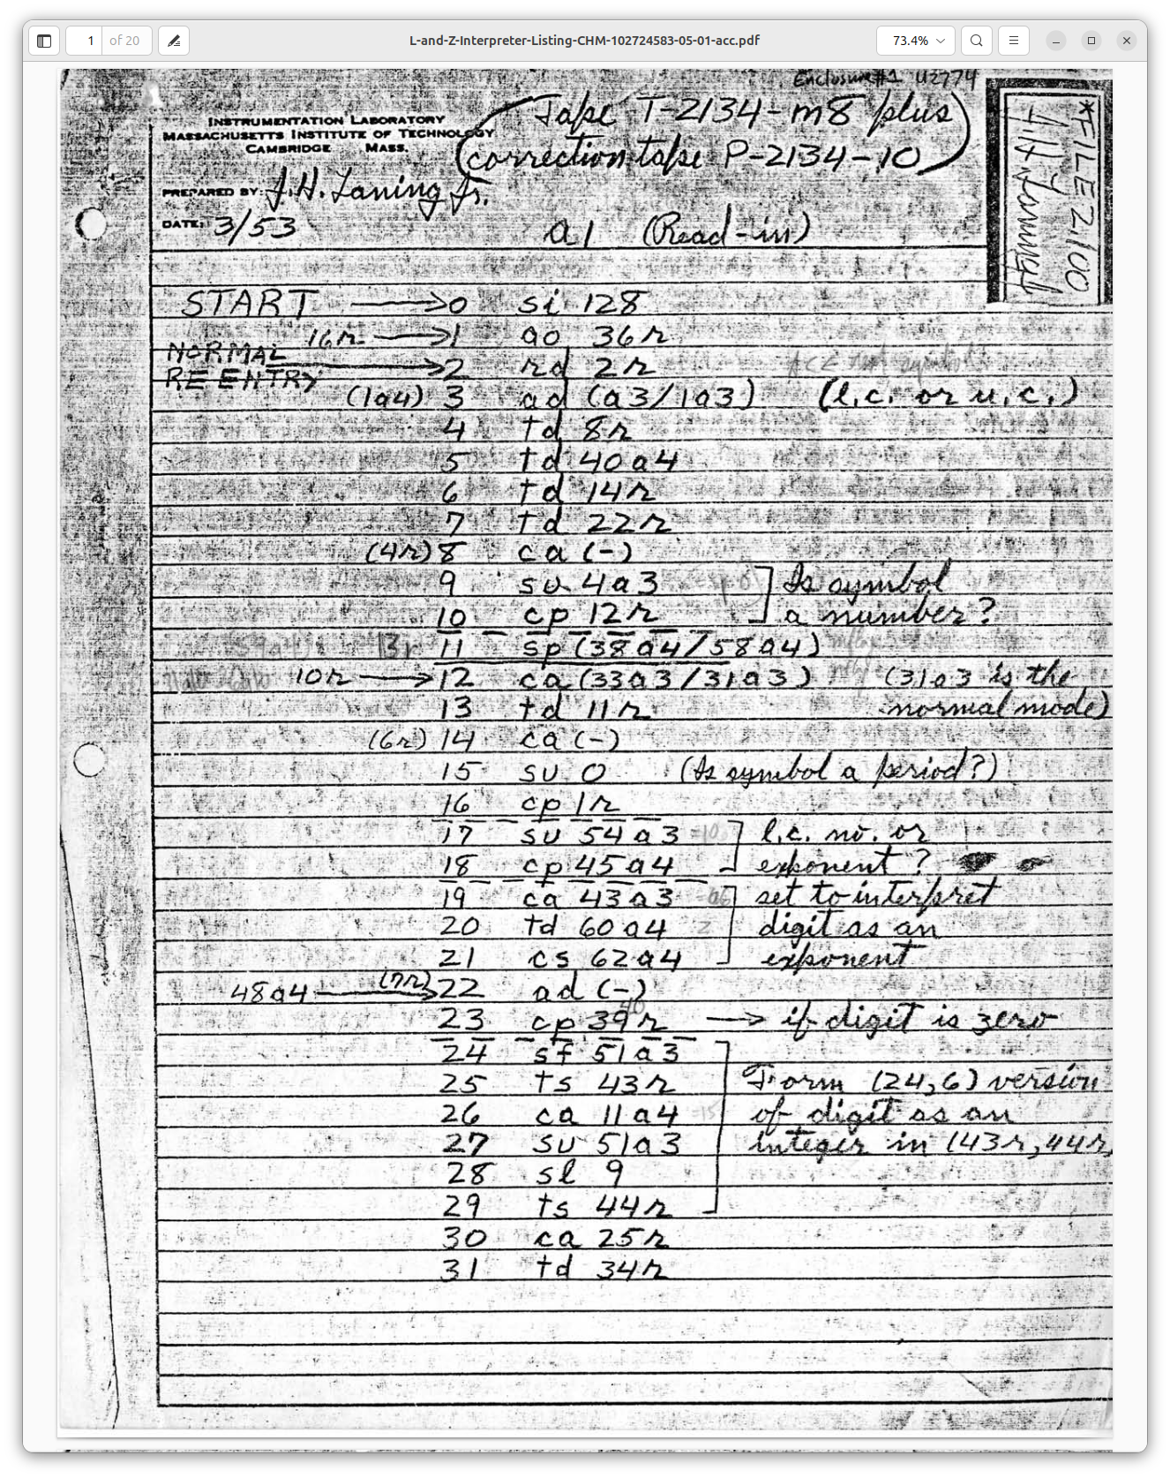Figure 2: First page of the Laning and Zierler Compiler-Interpreter.

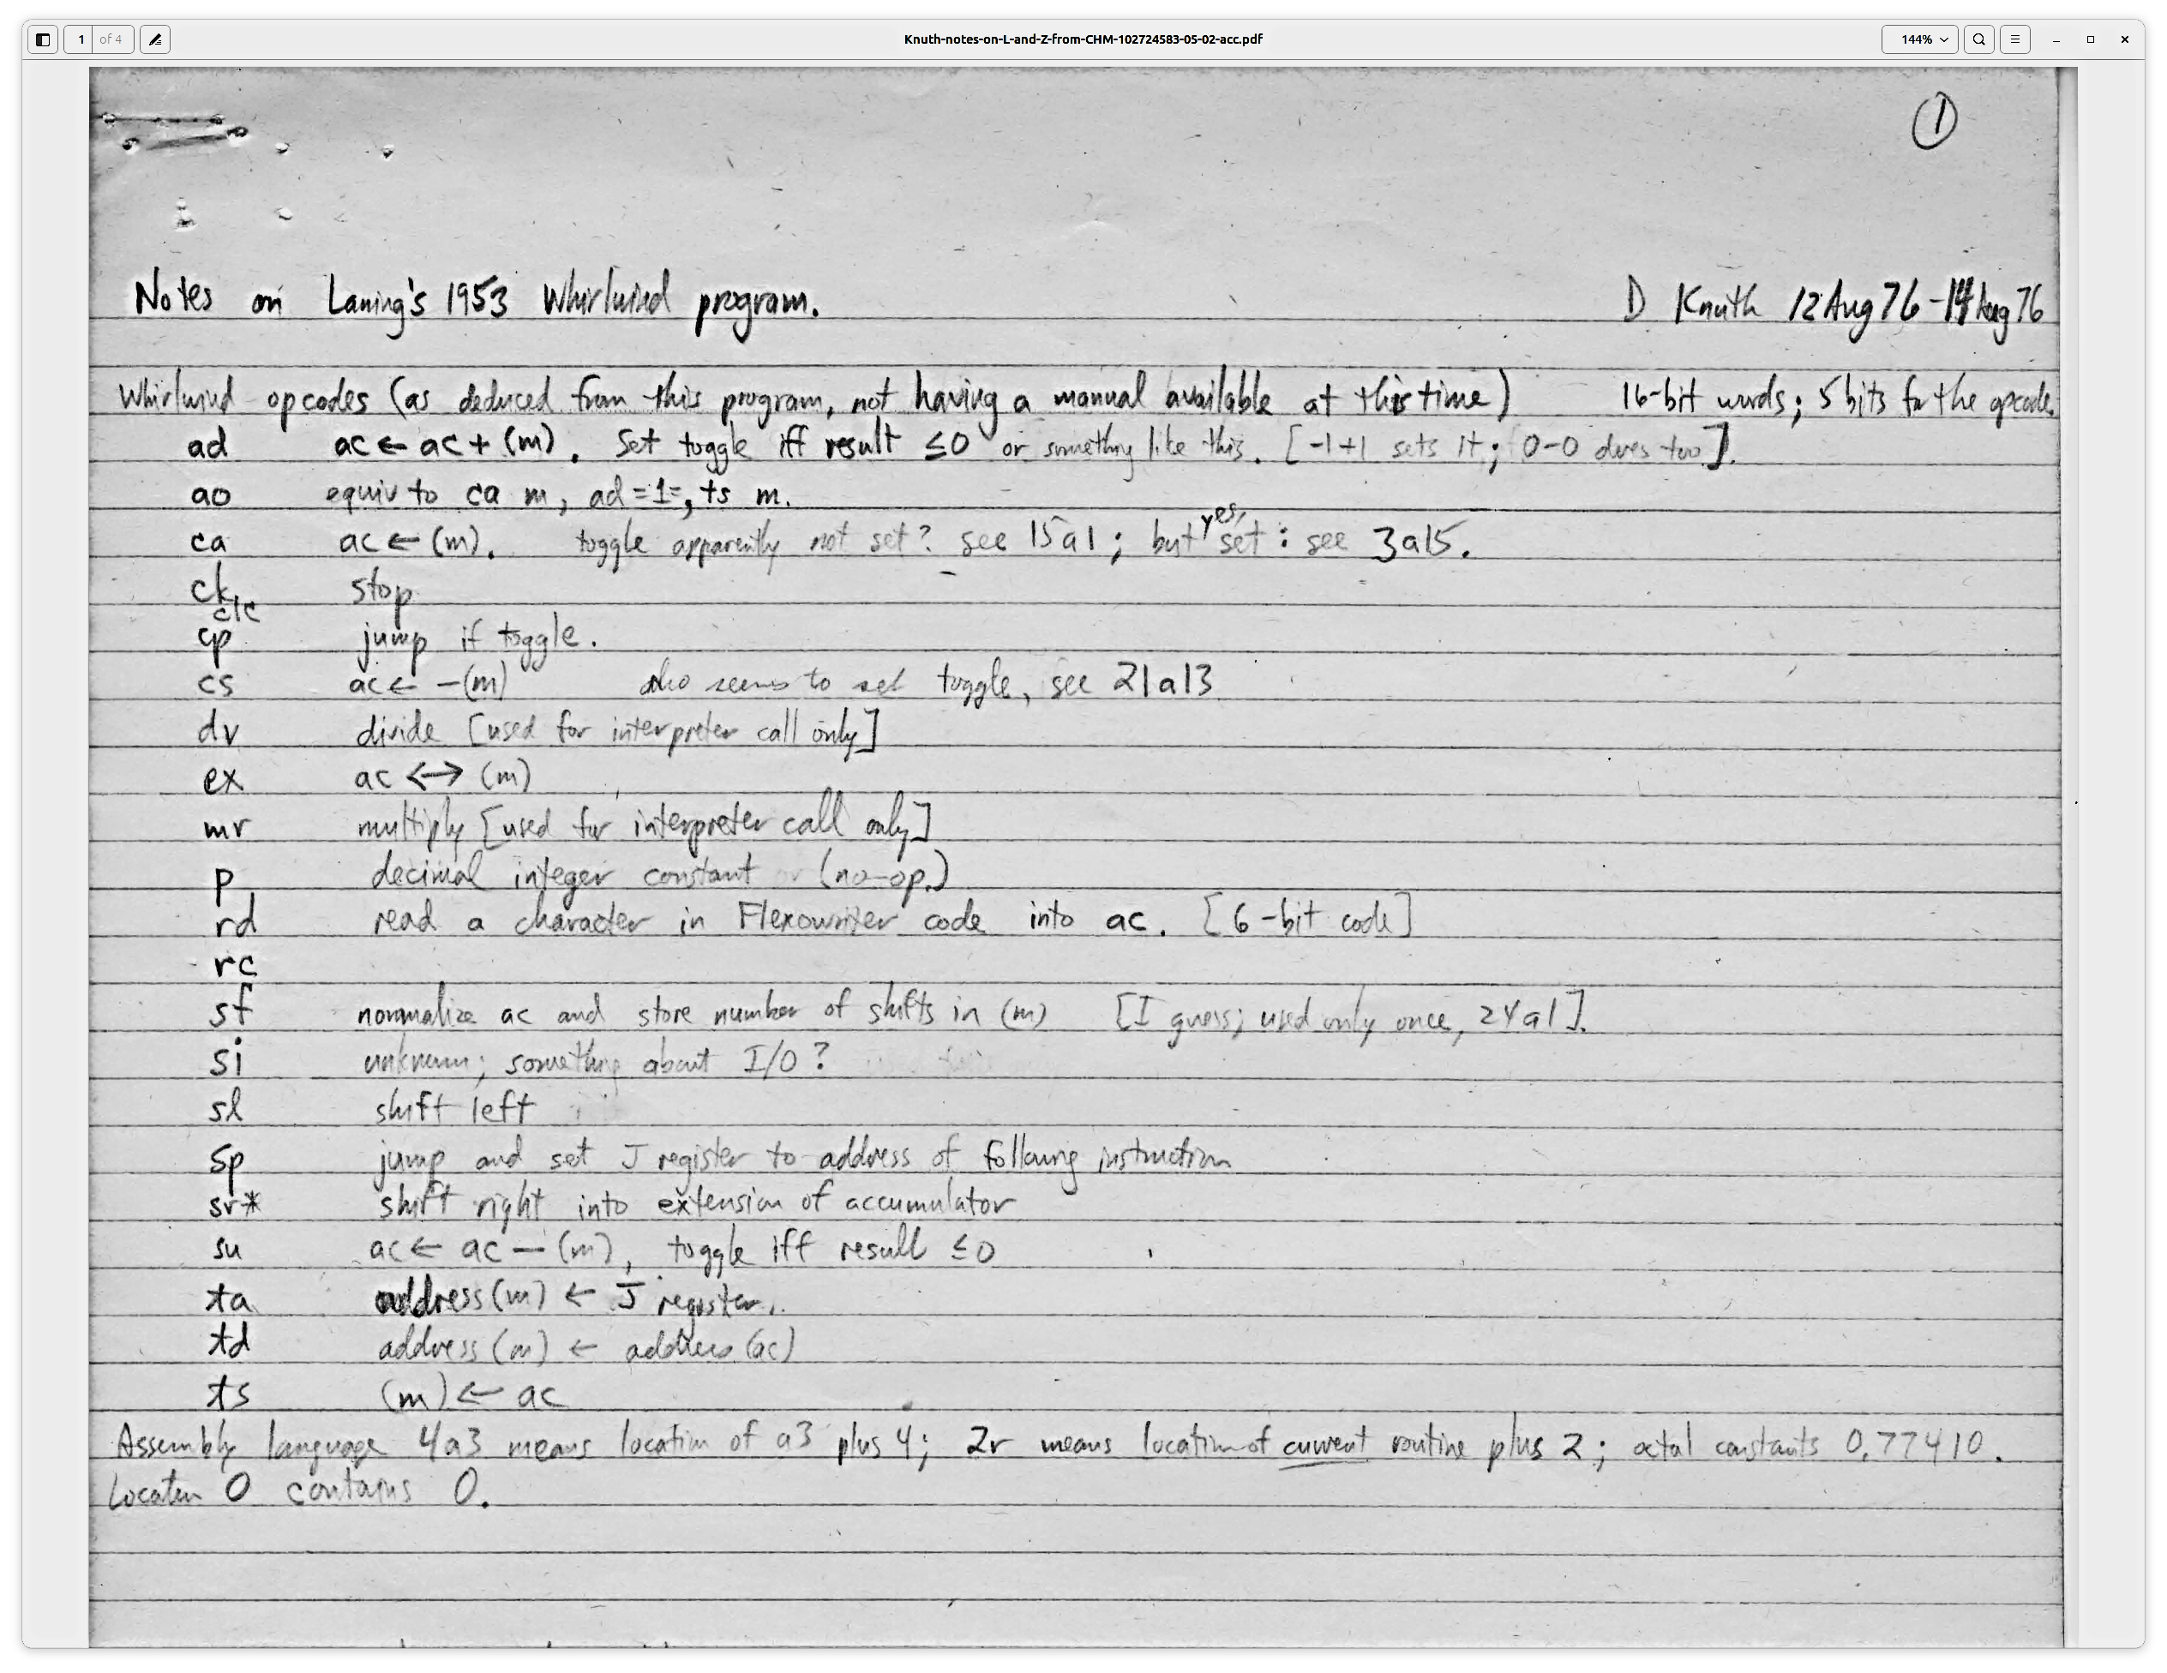Figure 3: Page one of Donald Knuth's 1976 analysis of the LZ program.

## Whirlwind in brief

The reference for this section is the 1958 Whirlwind Programming Manual, 2M-0277 [3].

Whirlwind was a 16-bit machine. Instructions had a 5 (sometimes 6) bit opcode, in the high end of the word, and 11 bits of address (or integer value) in the low end. Generally therefore 2K words of memory was available, though there were as time went on at least three 2K banks available (instructions were provided to switch among banks).

There was effectively a single accumulator, the AC. Some operations used an extension register BR. There was also an address register, AR, affected by changes in control flow.

Whirlwind was a one’s-complement machine – a real headache; in particular, both zero and negative-zero need to be accounted for. The advantage is mostly to hardware: to negate, just flip the bits. Saves several vacuum tubes!

In addition, numbers were all considered as fixed-point fractions. So there is a sign bit, then 15 bits of fractional value, e.g., 0.101010101010101. But the words are considered integers in the address fields of other instructions. Thus we have the instruction *dv* (divide), which alarms if the (fractional) numerator is greater than the (fractional) denominator, since the result would be one or more, and at the same time we have the instruction *ao* (add-one), which adds (integer) one (fraction 2-15) to the contents of a given memory location.

Fixed-point fractional was in fact a natural choice, given the application space of this machine, in real-time work, radar, and so forth. And to get better resolution, the developers wrote multi-precision fractional and floating point libraries. Floating numbers in storage used two words, in (24,6) format: 24 bits plus sign for mantissa, and 6 bit plus sign for exponent. The floating accumulator (the MRA, Multiple Register[1] Accumulator) used three words, a (30,15) format.

### The Great Unwashed

Whirlwind embraced tightly the principles of the von Neumann architecture, which combined program and data into a single memory. Thus the presence of instructions which wrote other instructions was not only permitted, but was a fundamental part of the machine architecture. In later days this became known as “impure code,” and spawned a lot of debate about instruction sets, and some mostly good-natured derision when programmers did not want to stick to the no-self-modifying-code dictum. There was a period, in the late seventies and early eighties, when the transition from on-the-fly self-modification to read-only code was made, as caching and pipelining made their way into the mainstream of computer design. So self-modifying code was sinful! [2]

But not so sinful for Whirlwind coders, as it was the only way to write compact code. To execute a set of operations on a block of numbers, for instance, one wrote the code as for the first number, then did *ao* (add one to the contents of a memory location) on each instruction that needed to advance to the next item in memory. So *ao* is used mainly for incrementing the address in an instruction. Note there is no *so* (subtract one).

To use this type of system well it’s advantageous to view a sequence of instructions on some given data as a specific machine, which is then modified on each pass.

### Instructions

The instruction set has similar basic attributes to later and latter-day instruction set architectures. A major notable difference between then and now is the Whirlwind instructions which directly support self-modification. The *td* instruction (transfer digits[3] to storage), for example, writes the AC into the address portion of an instruction word, thus altering the data that instruction will use when executed. Instructions take a single parameter, which in most cases is an address. In shifts and some I/O instructions the operand is an integer.

Instructions like *ca*, clear-and-add, are used to load the AC. There is also *cs*, clear-and-subtract, and *cm*, clear-and-add-magnitude. *ad* adds the contents to the AC, and *su* subtracts the contents. *dv* divides, *mr* multiplies and rounds to 16 bits, and *mh* multiplies and holds the full double-precision product in AC and BR.

*ts* (transfer to storage) stores the AC into memory. The *sp* (subprogram) instruction jumps to the given location, depositing the address of the instruction following (the return address) into the AR (address register). *ta* stores the AR into a memory location’s address field, effecting a save of the return instruction. c*p* (conditional program) jumps as does *sp*, if the sign bit of the AC is set. This can be true of a negative number or negative-zero.

A common pattern for subroutine entry and return is:

enter_subr: ta subr_rtn  
 ...subr instructions...  
 subr_rtn: sp 0

*ta subr_rtn* stores the return address (AR) into the *sp 0* return instruction’s address field, replacing the 0 or previous contents.

*si* selects an I/O device. *rc* writes to a device. *rd* reads from a device.

There are a few varieties of shifts, *slr*: shift left and round; *srr*: same only right. *slh*: shift left and hold (don’t round); *srh* goes right. These are arithmetic shifts and don’t shift the sign bit. *clc* (cycle left) shifts all bits.

Shifting can get complicated since it can extend to or from the B Register (BR). The BR is always considered positive, and negative numbers are complemented in the AC before and after a shift – except for *clc*, which shifts but otherwise leaves all bits untouched.

## The Floating-point Library

The floating point library (float lib) operates as an interpreter; the language it interprets looks just like Whirlwind machine language. The essential difference is that the float lib uses a three-word accumulator for floating numbers, the MRA (Multiple Register Accumulator), and stores floating numbers in two-word (24,6) format, as described above.

But the float lib also interprets other general-purpose instructions in addition to arithmetic, in particular *sp*, *cp*, and *ta*.Overall the float lib emulates a comprehensive virtual machine in interpreted form, which uses floating point numbers as its sole data type. These virtual-machine instructions are indistinguishable from standard Whirlwind instructions.

The interpreter is entered by calling the address with label *ax*, via *sp* *ax*. The instructions to be interpreted follow the call. Within the interpreted instruction stream, another occurrence of *sp* *ax* returns control to the calling Whirlwind code, at the location following the last *sp* *ax*.

By this method, code can jump in and out of the floating lib as desired to effect floating calculations. No state is kept between its invocations, except for the MRA. Thus one is free to jump in and out. Due to the labels involved, I call this “going in and out of spax,” or when code is interpreted it’s “under spax.”

Floating arithmetic is implemented straightforwardly, except for divide (*dv)*. Divide uses a second-order Taylor series approximation to 1/(a + kb), where a and b represent the high and low words of the mantissa of the denominator:

$$\frac{1}{\left(a+kb\right)}≈\frac{1}{\left(kb\right)}-\frac{a}{\left(k^{2}b^{2}\right)}$$

## The LZ System

### *A note about versions*

The version ported in this work is dated March 1953. Yet the documentation for the system, dated January 1954, describes features that are not in the 1953 version. Indeed Knuth signals the absence of certain apparently-planned features in his notes:

We have found in total that the following features were not yet implemented in the ‘53 version:

* Subscript and indexing syntax for variables.
* Drum-based buffer for indexed variables (for processing large vectors).
* SR and CR instructions, to call one-line subroutines within the language.
* A library of math functions, such as square root, sine, cosine, etc. The syntax of these is F1 = square root; F2 = sine; F3 = cosine, and so on.
* A “D” operator for differential equations (Runge-Kutta algorithm).
* Special processing of the Flexowriter “stop” character.

It seems odd that Knuth analyzed an incomplete version of the program in 1976, since the project overall took place 20 or so years earlier. And it’s also odd that Laning also included printouts of runs that used the later, complete version. It’s likely that this is what Laning had “lying around” and that tapes or other files were not readily accessible at that time. In our general investigations into Whirlwind code, we have many tapes, but we have only scratched the surface regarding the semantics of their content. It’s possible that an updated LZ system is there, and we continue our excavations.

### The LZ Language

Figure 1 shows a sample LZ program. This prints musical note frequencies, starting from A220, by successively multiplying by 21/12. It also demonstrates exponents, division, and printing by calculating note2, and 1/note2.

A number written next to a line is a label. CP jumps to its given label if the MRA is negative, so we get a conditional loop.

Expressions accept single-letter lower-case numeric variables (in later versions, with a “subscript” option[4]). Addition is indicated by +, subtraction by -, and division by /. Multiplication is denoted by juxtaposition (*e.g*., *xy* means *x* times *y*), but also by “dot” – not period, but colon, where they filed off the lower dot of the colon on one or two of the Flexowriters (see [5], page 12).

Exponentiation (by an integer) works by successive multiplication or division. It is indicated by true superscript characters, typed as upper-case numerals and upper-case -. This feature did not make it into ASCII and modern programming. Of course we can denote and print superscripts and much more today, but it’s not available via the same typewriter interaction as it was on the Flexowriter.

Parentheses may be used for grouping, up to four levels. Operator precedence order is exponentiation (highest), multiplication, division, and addition/subtraction. Typical modern languages hold division and multiplication at the same precedence. So in LZ, xy/zt = (xy)/(zt) whereas in (say) C, x*y/z*t = ((x*y)/z)*t. Laning was concerned whether this was implemented correctly, as indicated in his letter to Knuth in 1976:

The notion of operator precedence as a formal concept did not occur to me in 1953; I lived in fear that someone would write a perfectly reasonable algebraic expression that my system would not analyze correctly. [6]

The language is described in detail in [5].

### Processing LZ

The LZ system runs in two overall phases:

1. Compile the input source text into instructions to be interpreted. The instructions to run the musical-note example are shown in figure 4.
2. Execute the resulting instructions through the interpretation system. The interpretation system in this case is spax plus some special interpreters, such as for exponentiation or printing.

Figure 4: Debugger print of compiled musical-note LZ code.

dbg 1101> p comp_code,50,i

0o40(comp_code):

0o40 = SP 0o41

0o41 = SP 0o1662(equals)

0o42 = MR 0o776(val_1)

0o43 = AD 0o1733(temp)

0o44 = TS 0o1111(var_a)

0o45 = SP 0o1736(print)

0o46 = MR 0o1111(var_a)

0o47 = SP 0o50

0o50 = SP 0o1662(equals)

0o51 = MR 0o774(val_2)

0o52 = AD 0o1733(temp)

0o53 = TS 0o1155(var_y)

0o54 = SP 0o55

0o55 = SP 0o1662(equals)

0o56 = SP 0o1674(minus)

0o57 = MR 0o772(val_3)

0o60 = AD 0o1733(temp)

0o61 = TS 0o1175(var_x)

0o62 = SP 0o63

0o63 = SP 0o1662(equals)

0o64 = MR 0o1111(var_a)

0o65 = MR 0o1155(var_y)

0o66 = AD 0o1733(temp)

0o67 = TS 0o1155(var_y)

0o70 = SP 0o71

0o71 = SP 0o1662(equals)

0o72 = SP 0o1701(exponent)

0o73 = SI 0o1155(var_y)

0o74 = SI 0o2

0o75 = AD 0o1733(temp)

0o76 = TS 0o1145(var_z)

0o77 = SP 0o100

0o100 = SP 0o1662(equals)

0o101 = MR 0o770(val_4)

0o102 = DV 0o1145(var_z)

0o103 = AD 0o1733(temp)

0o104 = TS 0o1143(var_t)

0o105 = SP 0o1736(print)

0o106 = MR 0o1155(var_y)

0o107 = MR 0o1145(var_z)

0o110 = MR 0o1143(var_t)

0o111 = SP 0o112

0o112 = SP 0o1662(equals)

0o113 = MR 0o1175(var_x)

0o114 = SP 0o1667(plus)

0o115 = MR 0o766(val_5)

0o116 = AD 0o1733(temp)

0o117 = TS 0o1175(var_x)

0o120 = CP 0o2003

0o121 = SI 0o0

### *Phase 1: Parsing and Compiling*

The first phase, parsing and compiling, is done character-by-character, as each is read from the Flexowriter paper tape. Characters index into a dispatch table, which then executes a handler for a particular character. State changes are effected by altering the instruction stream, by saving data in certain fixed locations, and by allocating space in three buffers:

* The compiled code, denoted in the ported system by the label comp_code, but hard-coded in the original to address 32, and growing upward.
* Space for literal read values, like 3.14159. These are allocated at the end of the compiled code block, and grow down. In the original they were assigned address 197 (growing down).
* A parentheses stack, allowing for four-deep nesting.

#### Program self-modification

It was not possible to program the Whirlwind without using self-modifying code, due to the lack of index or address registers. The only way to load the AC for example is via instructions like *ca*, which only take an address in the instruction word as an operand. To operate on a block of words, *ao* is used to increment the address on the *ca* instruction.

Another technique used in LZ is to substitute one instruction for another, based on conditions in the program. For instance if a calculation needs to choose whether to do a divide (*dv*) or multiply (*mh*), detection of this causes the appropriate instruction to be read from some location and stored into the instruction stream. Note this will be a few words more compact than detecting the condition and branching to code that does either *dv* or *mh*, as then more code would be needed simply for the branches to and from that code.

In his notes, Knuth uses “flag names” to denote instruction switching. For example the “cflag” (case flag) follows the handling of the upper/lower case Flexowriter codes. Knuth defined several of these flags as stand-ins for the instruction rewriting, then used these flag names to annotate the listing. [4]

Another example or instruction rewriting is seen in reading digits. When a digit is read, a *cp* detects this and branches to a digit-handling section of code. That section rewrites the address of the instruction of the non-digit handler, *i.e.*, the code executed if the character is *not* a digit. This new target processes the number resulting from the digit sequence, and rewrites instructions again to return to a normal state.

#### Program reuse

Whirlwind programmers took advantage wherever they could of ways to optimize space. A couple of interesting examples are described here.

##### Who needs that dispatch table?

While reading characters, the dispatch table which drives each read obviously must remain intact. But when all the source is read and compiled, the table is no longer needed. When endowed with such a small memory, you look for every word.

Any lower-case letter may be a variable. A variable requires two words, for storing a (24,6) floating number. So the system uses those character entries for the actual values. But each character requires a word in the table, and a float value requires two words. What if there are two variables – two lower-case letters – consecutively stored in the table? Well, as it turns out, there aren’t! Each lower case letter has a non-letter character between it and the next letter; it’s a quirk of the Flexowriter character code. Whirlwind programmers were very astute at finding and exploiting these happenstance alignments.

##### Constants are wherever you find them

In another example, the fractional value -32767/32768, which equals -0.999969482421875 (exactly), integer -32767, is needed in some arithmetic code in the system. This is also the value of the instruction *ca 0*. By hardware convention, on Whirlwind location zero always contains zero, and there are places in the code where loading a zero is desired. So a *ca 0* which will never be written is ripe for the plucking as -32767. Taking advantage of the absolute or relative numeric values of instructions is another common technique used in Whirlwind programming.

#### Compiling expressions

As characters are read, and information about the expression to be calculated is accumulated, and parsing state altered, certain characters will terminate whatever is currently being built and call for one or more words to be added to the compiled code.

A certain call is made, *sp 9a8*, to add a word, in the AC, to the compiled-code heap. As a line is compiled, not only are words added, but previous words modified, resolving addresses as required.

There are code block patterns for each type of line (assignment, print, etc.). For instance the assignment of a variable to a single number:

a = 1.0594632,

results in this code:

0o40 = SP 0o41

0o41 = SP 0o1662(equals)

0o42 = MR 0o776(val_1)

0o43 = AD 0o1733(temp)

0o44 = TS 0o1111(var_a)

The comma terminator triggers the compilation of the last two instructions.

There is a basic pattern to the code blocks, whether they involve an *equals* assignment or calculation of an intermediate value:

* An *SP* placeholder, typically just a jump to the next instruction. But this allows modification to the subexpression evaluation order, which occurs in processing parentheses.
* A sequence of one or more multiplies, *MR*, or divide, *DV,* of the MRA and a value or variable.
* An *AD*, *SU* or call to *PLUS* or *MINUS*.
* A *TS* to a variable, if the code block is for *equals*.

### Phase 2: Interpreting the compiled code

Compilation proceeds until the STOP statement is reached. The generated code is interpretive code, so its execution is under spax.

Referring to the musical-note example in figure 4, at 0o41 equals is called. Equals simply loads 1.0 into the MRA, and zero into *temp*.The next instruction, *MR 0o776*, multiples *val_1* (1.0594632) by the MRA and leaves the result in the MRA. Then *temp*, which is zero here, is added, and finally *TS 0o1111* stores the result, in the fixed and former dispatch table entry for the letter “a”.

As mentioned, this code block is not emitted purely sequentially, with partial information filling-in until ultimate resolution.

Another code block type of note is that for print. The LZ line:

PRINT y,z,t.

results in:

0o105 = SP 0o1736(print)

0o106 = MR 0o1155(var_y)

0o107 = MR 0o1145(var_z)

0o110 = MR 0o1143(var_t)

0o111 = SP 0o112

In this case the print routine comes out of spax and does not interpret each *MR* as a multiply, but just gets its operand, the address of the variable to be printed. It then prints that variable and via *ao* moves on to the next *MR*.

To detect the end of the list, the code simply does a *cp* on the possibly-*MR* instruction. *cp* checks for negative (a set sign bit). *MR* has the sign bit set in its opcode (binary 11000), and no negative opcode can follow the *MR*. Thus it’s able to check reliably that the end of the print list has been reached. The opcode for *SP (*binary 01111)*,*  has the sign bit clear.

Using the relative numeric values of instructions is yet another good illustration of Whirlwind programmers cleverly optimizing, again taking advantage of patterns in the system design that were probably unintended.

The code continues to be interpreted until the zero instruction is reached. Here we run into a problem, because the LZ code does not add an “end program” or similar marker to the end of the compiled code, and without that the program crashes. This may be due to the 1953 code being an early version. In any event, for today’s purposes, since the calculation is done by that point, code was added to detect the zero and halt the machine.

## Comments on the development of the port

##### Chain-of-custody

Care was taken to assure that changes from the original hand-written text were tracked and marked, to show clearly where changes were needed or there were errors in transcription. Using Github’s history mechanism we can track the original transcript though edits and transformations, if such a level of detail is ever desired. However comments are formatted into separate fields in such a way as to retain most of the original listing’s comments *in situ*, separate from comments from the porting work. In this way changes from the original are noted without too much clutter.

##### Reading the hand listing

Several of the problems encountered were errors in transcribing the original hand listing. Sometimes just reading the handwriting was a challenge, but in addition the notation wasn’t always obvious, for instance the difference among, *sp 0*, *sp (0)*, or, *sp (-)* (operationally, none), or the use of double vertical lines in the code (this seems to indicate being under spax). Some lines were just left blank. Choosing some value and tracking down issues for each such case took some time. Knuth’s notes were helpful here.

Given all this, the code required only minor changes, with the exception of the address space issues, floating point accuracy, and float printing (see below).

##### Assembly language generation

Simple parsing tools allowed the translation of the raw transcript to our more modern-looking Whirlwind assembler. The tools looked for specific quirks in the transcript, such as parenthesized parameters. Labels were generated only for those addresses referenced by the code, thus avoiding lots of label clutter or the use of hard addresses. Labels were generated following the original format, <offset><section-name>, *e.g.*, 39a3. Once the automatic translation was finished, some hand-editing then followed for label names, corrections, and so forth. As mentioned above these edits were notated in comments.

In several cases mnemonic labels were added to aid readability, and these help for instance in the Whirlwind debugger, which was developed as part of the simulator. The full ported source code is available in [12].

##### Address space issues

The hand listing, Knuth’s notes, and other documentation indicate that allocation of addresses was still being done up-front by the programmer, as is shown on the coding sheet.

Some parameterization was available, via certain two-letter combinations which may be assigned by some automated means; this is the origin of the “ax” label for entry into the float lib. Nevertheless the hand listing says *sp 852* in various spots, and the entry point 852 shows up in other documents as well. Other hard-coded addresses (all decimal) are 32 (compiled code), 197 (value buffer), and 222 (float printer).

However when trying to see how the code would fit together, it just wouldn’t. Normally the origin address is 0o40 (32), so right away the standard code origin needs to change if the compiled code buffer remains at 32. Where should it go? The other fixed addresses didn’t help matters. So one change made to move forward was that all the hard-coded addresses were replaced with symbolic labels, and spaces for the buffers and code in question allocated in fixed-size, non-overlapping blocks, and then assembled using standard contemporary techniques. Importantly, staying under the 2K limit was retained.

##### Floating point printing

The hand listing says *sp 222* to do the float printing, but alas there is no such subroutine there. The existing documentation of such routines is in a file called Subroutines.pdf [10]. For instance it contains the floating point (spax) lib. It also contains a number of printers, such as for single- and double-precision fractions, but not for floats.

The double-precision fraction printer uses the *qp* instruction. This instruction was obsolete however by 1953, and it drove some unknown device whose character code is also unknown. So this routine was ported and converted to use the Flexowriter. The printing format is the fractional part of the numbers shown in the virtual Flexowriter (figure 1) and the Laning letter (figure 5).

To utilize the fractional printer for floats, some additional effort was required. First, by a naive algorithm running under spax, a floating number x is reduced to a fraction such that 0.1 <= x < 1.0, saving the resulting base 10 exponent. This results in a floating binary exponent e such that -4 <= e <= 0. Shifting the fraction (mantissa) right by |e| results in a denormalized two-word mantissa, whose printed representation as a fraction in decimal will be appropriate to a power of 10 multiplier. The exponent is then printed separately.

Adding the code to do this arithmetic exposed some accuracy issues, as described below.

##### The Flexowriter Window

The virtual Flexowriter originated as a simple demo, but then it was realized that it was a good way to get something close to the behavior of the actual machine, especially the superscript numerals and color ribbon shift. An ASCII format was developed to represent LZ code (with the modern ^<n> denoting superscript), which is then translated to Flexowriter codes for consumption by a Whirlwind program.

Similarly, Flexowriter codes are accepted directly by the virtual Flexowriter from Whirlwind, and printed to approximate the appearance of the original. Figure 5 shows a printout from a real Flexowriter device.

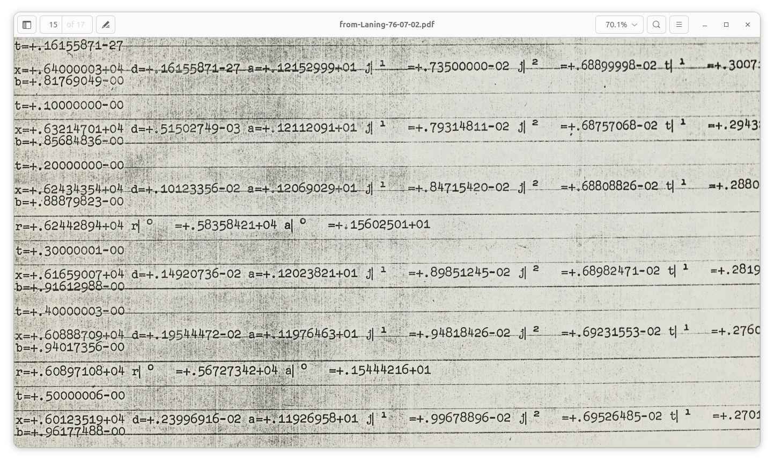Figure 5: Flexowriter printout of a partial LZ program and LZ run, from Laning's letter to Knuth [6], which contains the only known printouts of output from the original LZ.

##### Floating point accuracy

This has been one of the more challenging areas of this project, and there may be lurking issues. One fundamental problem is that, in the original code, shifting of packed words was not being done correctly. Signed and unsigned numbers were being packed into the same word, then bit-manipulated via complementing pre- and post-shift. This showed up as errors in numbers with negative exponents. Code was added to correct this, but it’s an odd thing to have slipped by the library writers, so we speculate that either the errors were likely corrected in later versions, or there is some machine behavior not being simulated properly.

Another accuracy and stability area still not completely resolved is floating point divide, and it is noted that none of the other multi-precision libraries support it. Some of the comments on the calculation appear to be inaccurate, for instance indicating x-squared or x2-squared, but with no squaring appearing at these points in the actual calculation. These errors just seem to be typos.

It’s also where *ca 0* is used as −32767/32768. Use of this value fails in certain test calculations, and why is yet to be determined.

Note that these issues belong to the float lib, and not to the LZ code proper. The float lib was transcribed from the typewritten Subroutines.pdf [10], which contains several modules for arithmetic and printing. Some of these are dated, the dates being late 1951 or early 1952. While the (24,6) float lib is not dated, one conjecture is that this is an early version that may have been corrected later.

## Conclusion

In developing LZ, Laning and Zierler effectively added layers of machine, each of which shares basic structure with the others. Starting with Whirlwind instructions, the floating point library implemented a machine very close to Whirlwind, with a different basic data type. In turn that was used to run code compiled from a language – which we’ve called LZ here – which is also structured much like Whirlwind.

The space constraints, and the urge – or need – to optimize every bit, mean that this development was very challenging. Laning notes this in his 1976 letter to Knuth:

The code used some rudimentary stacks, but was sufficiently intricate that I didn't understand it without extreme concentration even when I wrote it. I have tried to play "human computer" for a while this afternoon, to give you a simple example to work from, but failed. Structured programs were not known in 1953! [6]

The “impure” programming style, while confusing to us now, was seen in those days as the only way to make full use of memory, and was an attribute of machine architectures that lasted some years. As memories grew larger and the cost per bit fell, and as virtual memory and caches became common, it made a lot of sense to isolate the read-write portions of memory from the read-only portions of memory. Hence what we have today could be considered an amalgam of the von Neumann and Harvard architectures.[5]

LZ was a forerunner to Fortran, which is generally credited as *the* breakthrough high-level language. It was of course more widely used, as a flagship product of an already-large computer company. So it evolved rapidly, and quickly was supported on various computers and their peripherals. LZ, while interesting, was in some sense already somewhat isolated in that it was an academic project, with exotic I/O systems such as the Flexowriter. So it was hard to use outside that realm. Whether LZ influenced the design of Fortran seems to remain in debate; for instance see Backus’s comments that he thought his team was influenced by it, but then later said no never mind he wasn’t sure. [11]

An interesting note is that Fortran supported a capital-letters-only style from its inception and for many years thereafter, because IBM in those days stuck with the most fundamental character code and did not support lower case, much less superscripts. As time went on lower case was supported, and case-sensitive languages like C were developed, but superscripting, especially so easily typed as a shift, never made it into programming as such.

So the use of the Flexowriter was a significant influence on the LZ language, and that specific interactive style would never be seen again.

## Acknowledgments

Thanks to Guy Fedorkow, for providing a base for this work, to Professor Donald Knuth for providing code analysis and historical archives, and to Dag Spicer for introducing us to the Professor.

## References

1. Fedorkow, G., Whirlwind Simulator Documentation, https://github.com/gfedorkow/Whirlwind-Instruction-Simulator/blob/master/Documentation/Whirlwind-Development-Environment.pdf.
2. Ferranti, Photoelectric Tape Readers Brochure, 1959, <https://bitsavers.org/pdf/ferranti/brochures/Ferranti_Photoelectric_Tape_Readers_Brochure_Feb1959.pdf>. I do not know exactly what model was used on the Whirlwind.
3. Heart, F.E., *et. al.*, Whirlwind Programming Manual, Lincoln Laboratory Memorandum 2M-0277, 1958, http://www.bitsavers.org/pdf/mit/whirlwind/M-series/2M-0277_Whirlwind_Programming_Manual_Oct58.pdf.
4. Knuth, D., Notes on Laning’s 1953 Whirlwind Program, August 12, 1976, <http://www.bitsavers.org/pdf/mit/whirlwind/laning_interpreter/k-3-u2774-Whirlwind-notes.pdf>.
5. Laning, Jr., J.H., Zierler, N., A Program For Translation of Mathematical Equations for Whirlwind I, Instrumentation Laboratory, Massachusetts Institute of Technology, Engineering Memorandum E-364, January 1954, <https://archive.computerhistory.org/resources/text/Fortran/102653982.05.01.acc.pdf>.
6. Laning, Jr., J.H., Letter to Donald Knuth, July 2, 1976, <https://cs.stanford.edu/~knuth/from-Laning-76-07-02.pdf>.
7. Laning, Jr., J.H. *et al.*, Algebraic Interpreter Program Listing (hand-written coding sheet), 1953, <https://www.computerhistory.org/collections/catalog/102724583/>, or <http://www.bitsavers.org/pdf/mit/whirlwind/laning_interpreter/k-3-u2774-Whirlwind-program.pdf>.
8. Neff, Randall, Knuth Digital Archive Project, Computer History Museum, <https://archive.computerhistory.org/resources/text/Knuth_Don_X4100/PDF_index/KnuthDigitalArchive-Index.html>, 2007. Though not directly referenced in this document, there may be more in this archive related to the LZ system.
9. Pawson, Richard, The Myth of the Harvard Architecture, IEEE Annals of the History of Computing, 2022, Print ISSN: 1058-6180, Online ISSN: 1934-1547, Digital Object Identifier: 10.1109/MAHC.2022.3175612, <https://ieeexplore.ieee.org/document/9779481>  
   See also <https://metalup.org/harvardarchitecture/The%20Myth%20of%20the%20Harvard%20Architecture.pdf>.
10. Subroutines.pdf, 1951-1952, <http://www.bitsavers.org/pdf/mit/whirlwind/Subroutines.pdf>.
11. See <https://en.wikipedia.org/wiki/Laning_and_Zierler_system>, which excerpts [Backus, John Warner](https://en.wikipedia.org/wiki/John_Warner_Backus), [The History of FORTRAN I, II and III](https://web.archive.org/web/20050827031552/http://www.stanford.edu/group/mmdd/SiliconValley/Backus/backus.html), Proceedings First ACM SIGPLAN conference on History of programming languages, San Jose, California, USA. Archived from [the original](http://www.stanford.edu/group/mmdd/SiliconValley/Backus/backus.html) on 2005-08-27 (16 pages).
12. https://github.com/gfedorkow/Whirlwind-Instruction-Simulator/blob/master/Code-Samples/Laning-and-Zierler-Interpreter/l-and-z.ww

1. Whirlwind documentation uses the word “register” to refer to memory locations as well as components like accumulators.
2. The DEC PDP-8 is the last machine I recall clearly having to write using this impure-code style; this was in the mid-seventies. However later in the seventies I recall the Prime 100, 200, and 300 still required some degree of self-modifying code. See https://www.sysovl.info/pages/blobs/prime/programmercompanion/early_prime_instr_summary.pdf
3. In the Whirlwind documentation the terms *digit* or *binary digit* are used instead of *bit.* 
4. The syntax for this is that used for superscripts, along with vertical bar (“|”). So x|2 means x2. See figure 5, an excerpt from a Flexowriter printout as shown in a letter to Knuth from Laning [6]. Unlike modern fonts, the vertical bar on the Flexowriter is at the far left of the character cell, thus making the superscript look detached. The reason is unknown for the large space between the superscripted number and the “=” sign.
5. See Pawson [9] for an interesting discussion of the terms “Harvard Architecture” and “von Neumann Architecture.”